**Postman Reporting**

**Node.js Installation:** Download the node.js from <https://nodejs.org/en/download> and install.

**Newman Installation:** Install new man from CLI using the command “npm install -g newman”



**HTML installation:** Install new man from CLI using the command “npm install -g newman-reporter-html”



**HTMLExtra installation:** Install new man from CLI using the command “npm install -g newman-reporter-htmlextra”



**Export Collection:** collection export in local machine

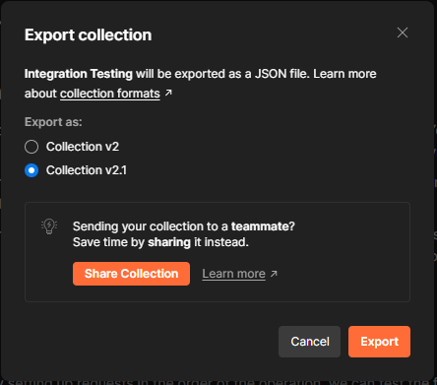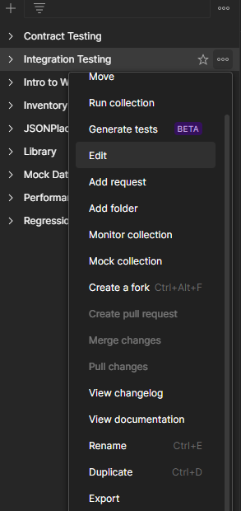

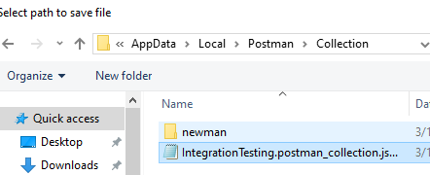

**Report Generation:** Go to CLI and go to the collection path in CLI



Write the command >newman run “Collection file name” -r htmlextra



New report will generate here

